It’s Student Council Spirit Week!
January 26-30, 2015

We’ve got spirit, yes we do! We’ve got spirit, how ‘bout you?
School Colors Day – Monday 1/26
Wear your Scott tee shirt or anything blue and white
to show your Alvah Scott PRIDE and SPIRIT! Don’t forget the smiles!


College Logo Day – Tuesday 1/27
Support your favorite college by wearing THEIR school colors or logo items. Clothing, lanyards, caps, and pom poms are all good!
Go University of Hawaii!! Green and white is alright!!

Wacky Wednesday – Wednesday 1/28
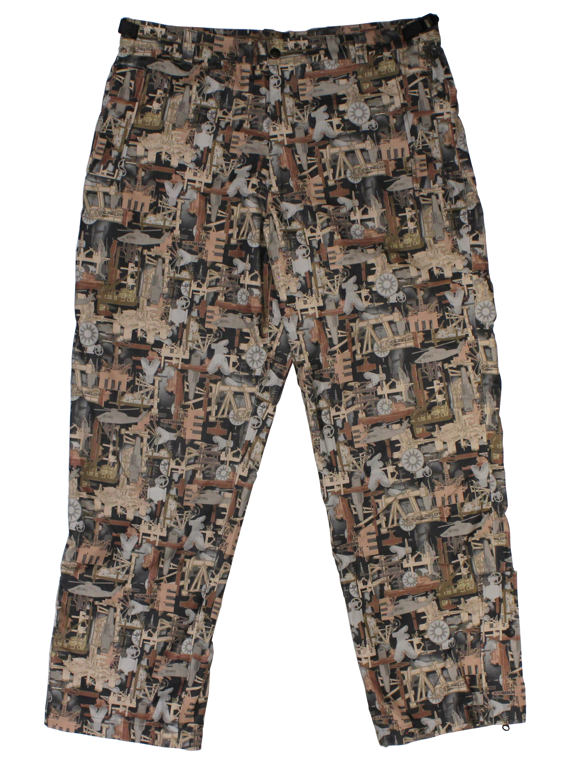
Be wacky, be bold, have fun! Show your wacky side by dressing up in silly/mismatched clothes, funny hats,
accessories, and wear a goofy hairstyle!

Sports Day – Thursday 1/29
Appear in your gear! Be the sports authority.
Wear your sports uniform and bring in your equipment. Just do it!

Culture Day – Friday 1/30
Share your culture by dressing up, sharing traditions,
stories, photos, or anything that would help your
classmates get to know you better!

